Process for sorting through Nisqually salmon data from Craig

Data from three fisheries provided: Green River Chinook, LocNis Chinook, and Winter Chum

**LocNis**

LocNis data is arrival at RM 13, which Craig estimates is 1 week above the gauntlet. I’m interpreting the weekly % as the proportion of the run that is at RM 13 in that week (total present, not number arriving). I’m assuming that all days within that management week are identical and have the same abundance as the overall weekly proportion. He estimates early to mid-July is a good starting point for when they enter the gauntlet, though the data currently doesn’t start until management week 32 (august 6th) because that’s when they started fishing. I’m adding 1% weekly for management weeks 30 and 31 which brings it back to July 23rd at RM 13 as a conservative guess for what was happening before fishing opened. RM 13 is 1 week above the gauntlet so I shifted the whole distribution 1 week earlier to cover their travel time from the gauntlet. So, the daily # in the Gauntlet is:

# on day t-7 = (week % * average run size)

So now the fish are estimated to be in the Gauntlet from management week 29 to 45, roughly July 16th – Nov 5th. (highlighted cells are ones I messed with or made up)

|  |  |  |  |  |
| --- | --- | --- | --- | --- |
| wk | ish | RM 13 | Gauntlet | Est (* 630) |
| 29 | 16-Jul |  | 1% | 6.3 |
| 30 | 23-Jul | 1% | 1% | 6.3 |
| 31 | 30-Jul | 1% | 4% | 24.23077 |
| 32 | 6-Aug | 4% | 0% | 0 |
| 33 | 13-Aug | 0% | 4% | 24.23077 |
| 34 | 20-Aug | 4% | 5% | 32.30769 |
| 35 | 27-Aug | 5% | 4% | 24.23077 |
| 36 | 3-Sep | 4% | 9% | 56.53846 |
| 37 | 10-Sep | 9% | 14% | 88.84615 |
| 38 | 17-Sep | 14% | 6% | 40.38462 |
| 39 | 24-Sep | 6% | 8% | 48.46154 |
| 40 | 1-Oct | 8% | 5% | 32.30769 |
| 41 | 8-Oct | 5% | 9% | 56.53846 |
| 42 | 15-Oct | 9% | 8% | 48.46154 |
| 43 | 22-Oct | 8% | 14% | 88.84615 |
| 44 | 29-Oct | 14% | 9% | 56.53846 |
| 45 | 5-Nov | 9% | 1% | 8.076923 |
| 46 | 12-Nov | 1% |  | 0 |

He also estimates that they likely spent less time in the gauntlet than GR because they’re brighter. Since he estimates 1-3 weeks for GR, I think maybe 1 week is a good starting point.

This arrival data is not a nice normal distribution. Right skewed, and highly irregular. I’ll start with a poorly fitting normal, but flagging that this could use refinement. Maybe a skewed beta eventually?

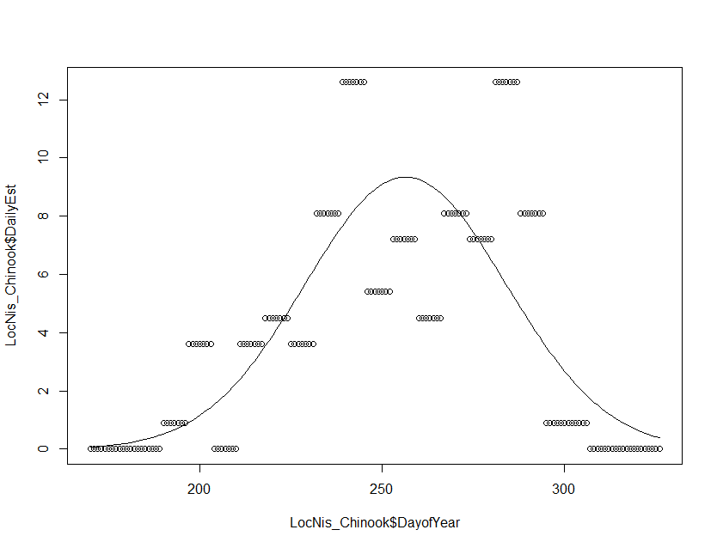

Mostly seal predation, gauntlet is delta and estuary.

Residence time: 1 week

Enter Gauntlet: early to mid-July (16th)

Leave Gauntlet: early November (5th)

Run size: 300-1400, average 630

**Green River**

Craig provided timing curve expressed as % timing through gauntlet, which I’m interpreting as % of run in residence at the gauntlet during that week.

|  |  |  |  |
| --- | --- | --- | --- |
| wk | ish | % timing through gauntlet | Est (*22k) |
| 29 | 13-Jul | 0.16% | 35.18451 |
| 30 | 20-Jul | 0.19% | 41.90667 |
| 31 | 27-Jul | 1.15% | 252.7802 |
| 32 | 3-Aug | 2.42% | 533.1833 |
| 33 | 10-Aug | 7.31% | 1607.925 |
| 34 | 17-Aug | 12.40% | 2727.358 |
| 35 | 24-Aug | 15.65% | 3442.176 |
| 36 | 31-Aug | 19.99% | 4397.362 |
| 37 | 7-Sep | 16.39% | 3605.773 |
| 38 | 14-Sep | 10.79% | 2374.228 |
| 39 | 21-Sep | 6.56% | 1443.645 |
| 40 | 28-Sep | 5.05% | 1111.918 |
| 41 | 5-Oct | 1.67% | 366.8311 |
| 42 | 12-Oct | 0.21% | 47.13183 |
| 43 | 19-Oct | 0.04% | 8.416399 |
| 44 | 26-Oct | 0.02% | 4.180805 |

Looks like a nice normal distribution, should be easy to replicate.

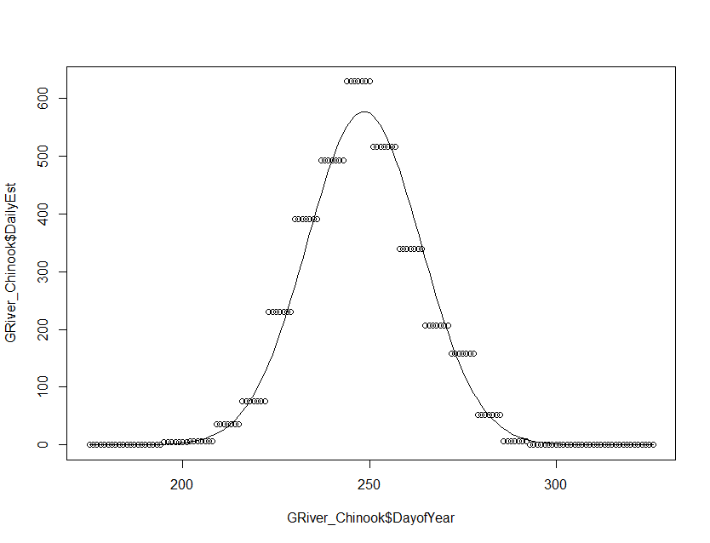

He estimates 1-3 weeks in gauntlet based on fish brightness and condition.

Mostly seal predation, gauntlet is delta and estuary.

Residence time: 1-3 weeks

Enter Gauntlet: July 13th

Leave Gauntlet: October 31st

Run size: 6,000-42,000, average 22,000

**Winter Chum**

Here Craig provides % of run in the gauntlet weekly.

|  |  |  |  |
| --- | --- | --- | --- |
| man. wk | ish | chum timing guantlet based on recent catch data | est (* 27k) |
| 47 | 16-Nov | 2% | 540 |
| 48 | 23-Nov | 4% | 1080 |
| 49 | 30-Nov | 10% | 2700 |
| 50 | 7-Dec | 17% | 4590 |
| 51 | 14-Dec | 21% | 5670 |
| 52 | 21-Dec | 19% | 5130 |
| 53 | 28-Dec | 15% | 4050 |
| 54 | 4-Jan | 9% | 2430 |
| 55 | 11-Jan | 2% | 540 |
| 56 | 18-Jan | 1% | 270 |

For Chum we’re defining the gauntlet as the whole area from the river mouth through wherever the fish spawns, and the “escape” rate is actually successful spawning. Need to think about what this means for estimating the time fish spend from entering the gauntlet to spawn.

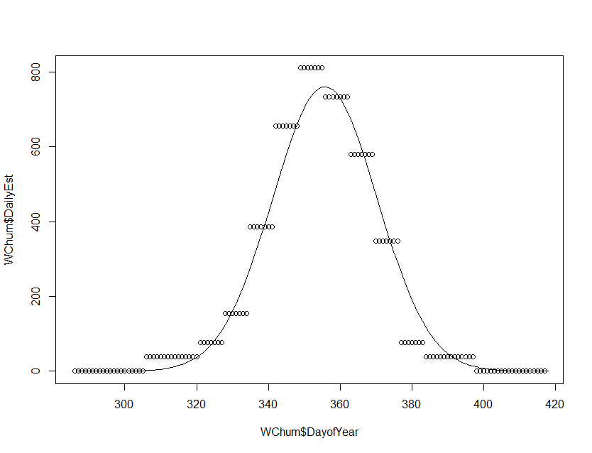

Residence time: 1-3 week in normal gauntlet, 1 week while trying to spawn in the gauntlet.

Enter Gauntlet: November 1

Leave Gauntlet: January 31

Run size: 2,000-62,000, average 27,000

Response from Craig Aug 6th:

*I do think the chum is complicated because the timing info is from our fishery and the gauntlet encompasses a greater geographic area on both ends of the migration (mouth RM 0- spawning RM 26+ tribs) than our fishery (RM 0.5 to RM 6).*

*I think that 1-3 weeks is reasonable for time spent within the “normal gauntlet” and another week for the “spawning ground gauntlet”. I am not really sure how to separate these. Maybe create two guantlets? The lower gauntlet Rm 0 – Rm 3 with residence time of 1-3 weeks with higher predation and an upper RM 3- Rm 26 (residence 1 week) with a lower predation but different impacts due to selection off the spawning grounds?*

*4 weeks for entry to successful spawning.*

My response:

I agree that Chum is complicated. I'm tempted to run a separate model for them than for the two Chinook runs so we can play around with different gauntlet processes. I realize there is some temporal overlap between LocNis and Chum though so that may not make a ton of sense.

If we run with the 2 gauntlets idea, would I be right in characterizing them as:

Gauntlet 1 (mouth - RM 3) high predation, seals and sea lions, residence of 14 days on average.

Gauntlet 2 (RM 3 - 26) low predation, mostly (all?) sea lions, residence of 7 days until spawning success.

I would put them sequentially, so fish that "escape" gauntlet 1 would then get passed on to gauntlet 2. Fish that "escape" gauntlet 2 get to spawn successfully. This assumes that no spawning is happening in gauntlet 1 though, which may not be true? Are they spawning before RM 3?

If they are, I think it would be easy enough to subset the ones that "escape" gauntlet 1 so that some proportion spawned successfully and the ones left over still have to face gauntlet 2. In that case we would need to estimate what proportion of spawning happens below RM3 but you may have data for that from redd surveys?

Thinking about the Pinniped Components

Jed expressed that Pv haulouts in/near Nisqually are pretty fractionated – lots of small ones not one or two big ones, so that might affect information spread.